**Project Design Phase-II**

**Data Flow Diagram & User Stories**

|  |  |
| --- | --- |
| Date | 16-06-2025 |
| Team ID | LTVIP2025TMID53111 |
| Project Name | House Hunt : Finding Your Perfect Rental Home |
| Maximum Marks | 4 Marks |

**Data Flow Diagrams:**

he DFD for **House Hunt** represents the flow of information between key actors (tenant, landlord, admin) and system components. It outlines how data like property listings, user profiles, bookings, payments, and messages are processed and stored

Example: DFD Level 0 (Industry Standard)

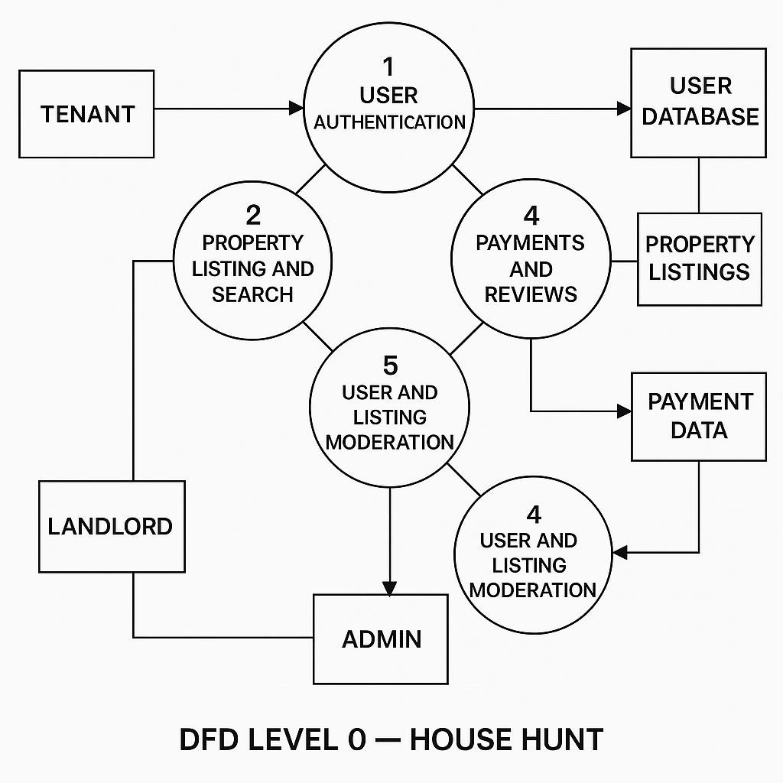

**User Stories**

**User Story Table – DocSpot**

|  |  |  |  |  |  |
| --- | --- | --- | --- | --- | --- |
| **User Type** | **Functional**  **Requirement**  **(Epic)** | **User Story / Task** | **Acceptance**  **Criteria** | **Priority** | **Release** |
| **Tenant** | Property  Discovery &  Booking | As a tenant, I can search for rental properties by location, budget, and features. | Listings returned based on filters and relevance.. | High | Sprint-1 |
|  | Booking Visits | As a tenant, I can book, reschedule, or cancel property visits. | Visit status updates dashboard  . | Medium | Sprint-2 |
| **Landlord** | Listing  Management | As a landlord, I can create and update property listings with images and availability. | Changes reflect immediately in pati booking system. | High  e | Sprint-1 |
| **User** | Messaging | As a user, I can chat with the other party in realtime | Messages appear instantly. | Medium | Sprint-2 |
| **Admin** | Profile  Management | As a Admin, I can update my profile. | Changes are saved successfully. | High | Sprint-2 |
| **Client** | Payment Processing | As a client, I can make secure payments after job completion. | Payment recorded and shown in transaction history. | High | Sprint-2 |
| **user** | Review System | As a user, I can leave a review after project closure. | Review appears on profile. | Medium | Sprint-2 |
| **Admin** | User Moderation | As an admin, I can review reported users and take action. | Reports and actions logged. | High | Sprint-1 |